Destructive Changes (Un-Deploy)

## (Procedure to delete the components from Salesforce Org using destructive pipelines)

## Branches required to select to un-deploy from:

FT: Integration

SIT: Develop

PP: Release

Prod: Master

## Merge Request:

https://git.eon-cds.de/hcl-da/salesforcedevops/sfundeploycomponents/-/merge_requests/141

View File

Switch to respective branch

Edit destructiveChanges.xml and Update the Components

Commit Changes

Go to the Pipelines

Click on arrow > and undeploy

Go running pipeline and check the undeploy job

Success and errors can be seen here.

## Example:

Performed to Delete/Un-deploy the components from FT2

Create a feature branch from Integration for below project

<https://git.eon-cds.de/hcl-da/salesforcedevops/sfundeploycomponents>

Clone below repo for Destructive changes:

ssh://git@ssh.git.eon-cds.de:22222/hcl-da/salesforcedevops/sfundeploycomponents.git

Checkout the feature branch

Add component in below file as captured below:

**destructiveChanges.xml**

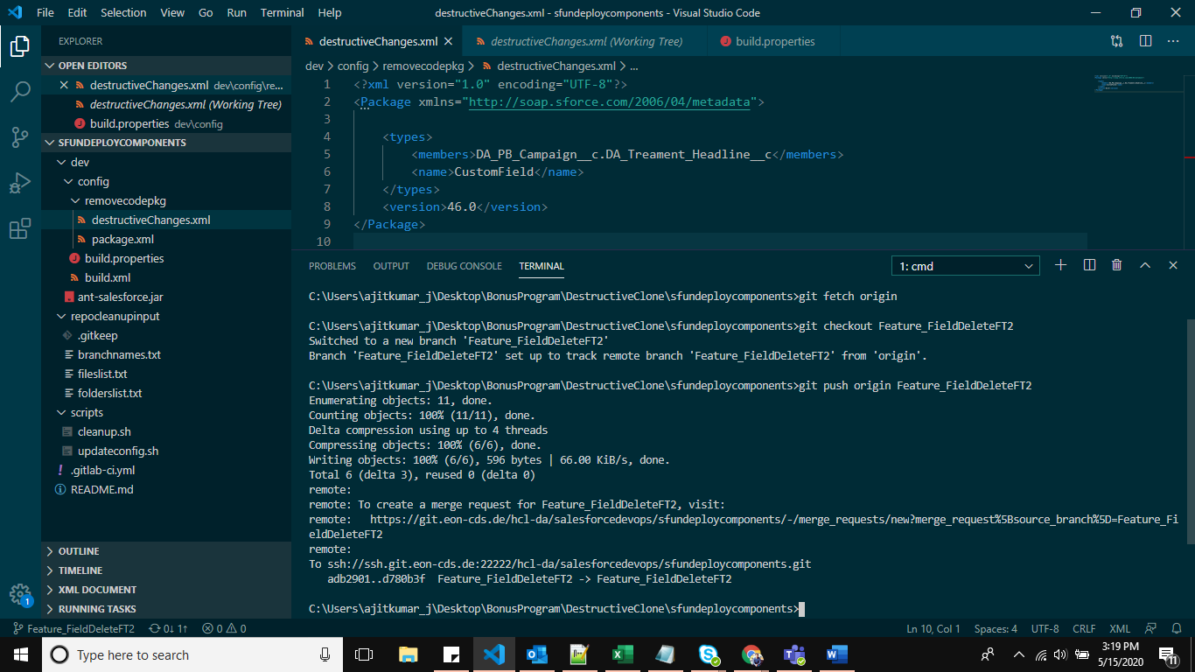

Stage Changes > Commit with Comments > Push the changes > Create the Merge Request from Integration Branch

go to the Pipeline: <https://git.eon-cds.de/hcl-da/salesforcedevops/sfundeploycomponents/pipelines>

Click on the first step “undeploy” as captured below:

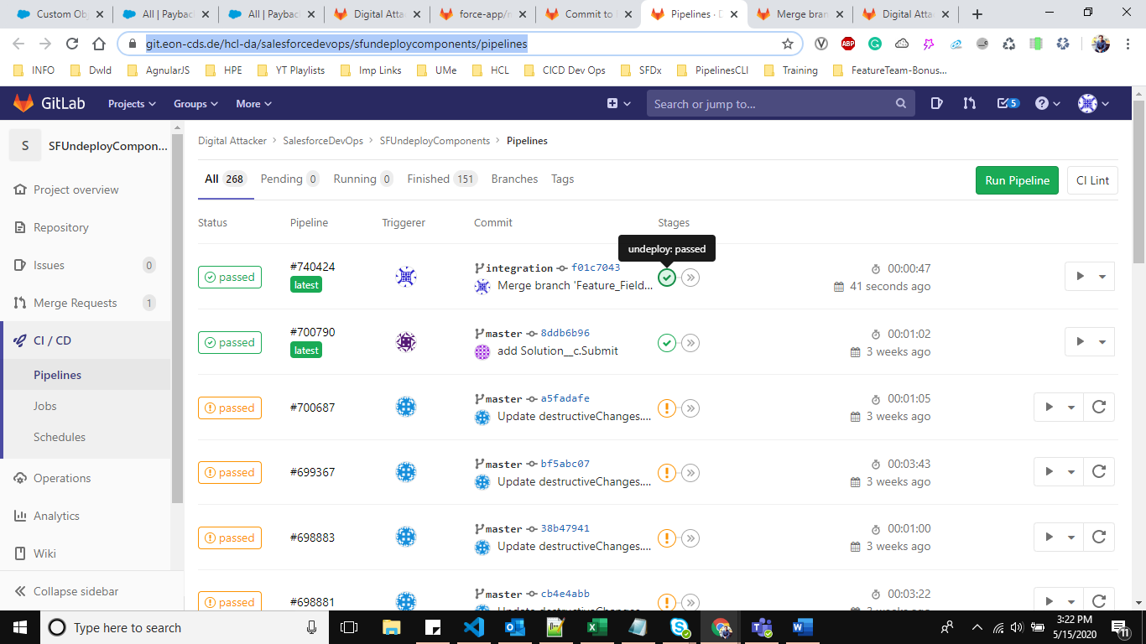

<https://git.eon-cds.de/hcl-da/salesforcedevops/sfundeploycomponents/-/merge_requests/90>

